Cypher City Hip Hop Music Festival 2025 Sponsorship 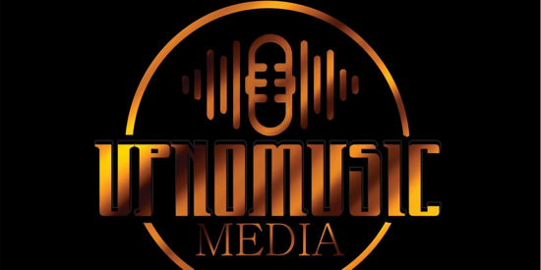
---

Ryan James
Head Festival Organizer
Cypher City Hip Hop Festival 2025 

Dear Potential Sponsor

**Subject: Sponsorship Opportunity for Cypher City Hip Hop Festival 2025**

I hope this letter finds you well. My name is Ryan James, and I am the Creator and Head Organizer of Cypher City Hip Hop Festival 2025, an exciting celebration of hip-hop culture taking place in Mansfield, Ohio. We are thrilled to announce this year's event, which promises to be bigger and better than ever before, and we would like to invite your company/ Business to join us as a valued sponsor.

Cypher City Hip Hop Festival 2025 will be held on Saturday July 26th, 2025, at Richland County Fairgrounds Youth Hall & Nature Park and will feature an impressive lineup of hip-hop 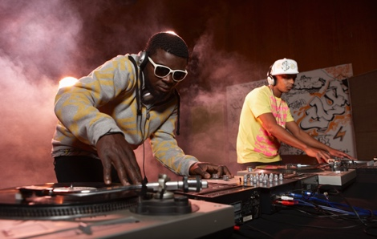artists, DJs, dancers, and graffiti artists from across the state Our festival aims to celebrate and showcase the diverse elements of Hip-Hop culture while providing a platform for both established and emerging talent.

As a sponsor, your company will have the unique opportunity to connect with our vibrant and engaged audience, enhance your brand visibility, and demonstrate your commitment to supporting the arts and local community. We offer a range of sponsorship packages designed to suit different levels of involvement and investment:

1. **Platinum Sponsor** - $800.00
- Exclusive naming rights for the main stage
- Prominent logo placement on all event marketing materials, including posters, flyers, and social media
- VIP access for 10 guests
- Opportunity to distribute promotional materials at the event
- Recognition during event announcements

2. **Gold Sponsor** - $400.00
- Logo placement on event marketing materials and social media
- VIP access for 5 guests
- Opportunity to distribute promotional materials at the event
- Recognition during event announcements

3. **Silver Sponsor** - $200.00
- Logo placement on event marketing materials
- VIP access for 2 guests
- Recognition during event announcements

4. **Bronze Sponsor** - $100
- Logo placement on event marketing materials
- Recognition during event announcements

We are also open to discussing customized sponsorship packages to meet your specific needs and goals.

Your support will help us bring this vibrant and inclusive celebration to life, and in return, we are committed to delivering exceptional value and exposure for your brand. We would be honored to have your company/business as a sponsor and look forward to the possibility of partnering with you.

Please feel free to contact me at upnomusicmedia@gmail.com Cell 419 914-1952 to discuss this opportunity further or if you have any questions. Thank you for considering our request. Together, we can make Cypher City Hip Hop Festival 2025 an unforgettable event for all.

Warm regards,

Ryan James
Festival Creator and Head Organizer
Cypher City Hip Hop Festival 2025
upnomusicmedia@gmail.com
Cell -419 914-1952

